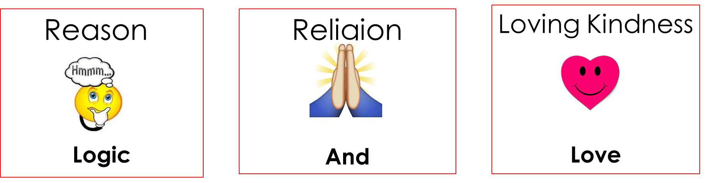
WWJD?
WWJS?
Strong Loving Relationships
1) STOP THINKING!!

2) Use a One-Liner

Our responsibility as parents is not to raise children.
Raise Adults
Our responsibility as parents is to _______________________.
Attention Control
Like us, our children seek _____________________ and _________________________.

A primary skill we can teach our children is to become ____Confident_ as ____Decision __-___Makers________ and _____Problem _-__Solvers__________.

__________________________________________________________________________________________
Loving Kindness/Love: Strong Loving Relationships
Foundation of love, respect, encouragement, and empathy

- Make every _Hello__ and __Good-Bye__ a special event.

- At least once a day, notice Something Special about them.

- Take a few minutes each day ___to connect with them__.

- Love them even when __they are not behaving lovable__.

Religion:

__________________________________________________________________________________________
Reason/Logic: Putting an End to Arguing, Back Talk, and Begging
TIPS:
- Be empathetic.
- Allow child to own problem.
- Be lovingly engaged by caring, not by solving.
1) STOP THINKING!!
2) Use a One-Liner

Examples of One Liners
- __Thank you for Sharing________ - __I love you too much to argue.
- ___That’s a Bummer_________ - _So sad_____________________
- ___That sounds difficult______ - I Know_____________________
- Hmmmmmm________________ - _Ahhhhhhh________________
- _Nice Try___________________________ - _Wow (softly)________________

The One-Liner I would like to use is:
- _______________________________________________________
“It is not enough to ________young,
they must know __________________!”
- Saint John Bosco

